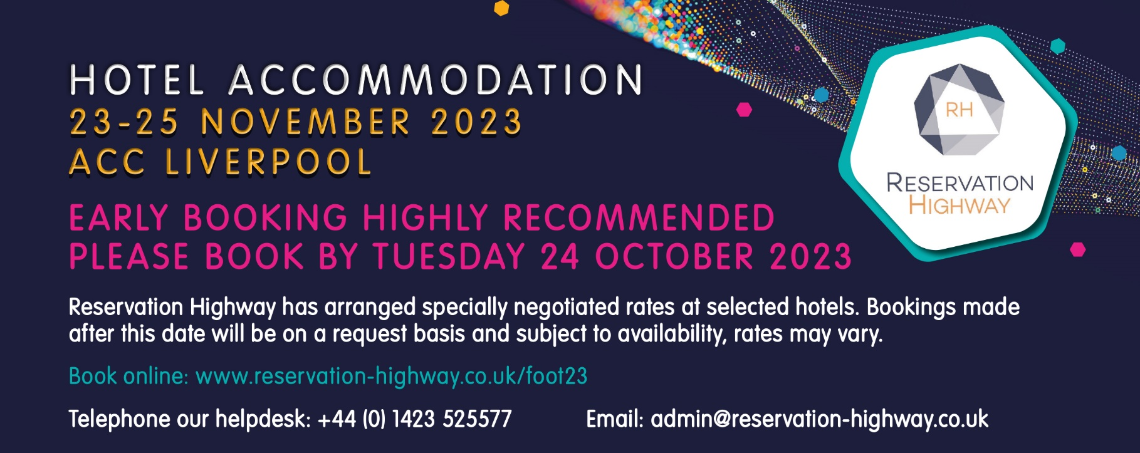

Please select: | ☐ Delegate | ☐ Exhibitor | ☐ Exhibition visitor
Name (contact)
Company name
Address  (Including Country) | Postcode:
Telephone
Email
Bookings are confirmed by email, please print clearly.
Hotel 1st Choice
Hotel 2nd Choice

Guest names | Room type | No. of guests | Arrival date | No. of nights
NB: When there are no single rooms available a double or twin for single occupancy will be allocated automatically.
Please indicate how you wish to secure your booking:
☐ Proforma invoice to be sent  (payment to be made in full 21 days prior to arrival) |  | ☐ Credit card guarantee  (payment made to the hotel direct on departure)
Card type: | ☐ VISA | ☐ MASTERCARD | ☐ AMEX  (not accepted by all guesthouses)
Card no. | -- -- -- -- / -- -- -- -- / -- -- -- -- / -- -- -- -- | Expiry date: | -- -- / -- --

Security digits may be required by some hotels to complete the transaction,
please give a contact telephone number below where the cardholder can be contacted.
Telephone:
No charge is taken from this credit card by reservation highway.
The card is used to guarantee your accommodation with the hotel. They may charge the card for non-arrival or late cancellation (cancellation policy for 9 rooms or less is 7 days prior to arrival unless otherwise stated on your confirmation.) All hotel accounts must be settled upon departure. Reservation Highway Ltd Wells House 8 Cold Bath Road Harrogate North Yorkshire HG2 ONA. Company Reg No. 04518087.

